1.VPC Creation With CIDR 10.0.0.0/16:(16 bits Fixed):(My-Vpc)

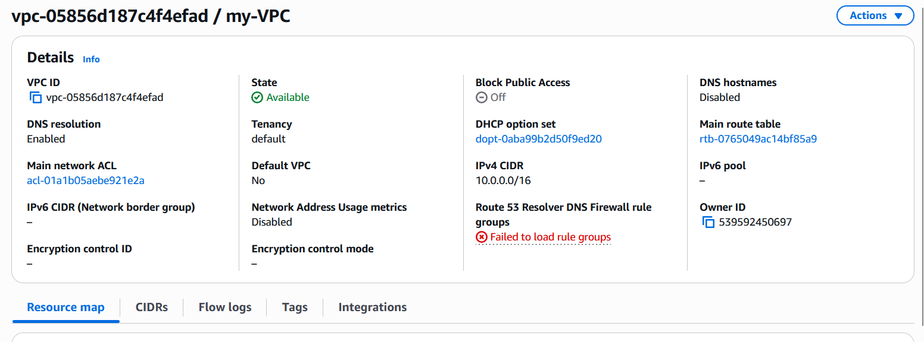

2.Attaching(my-Vpc) VPC with Internet Gateway:

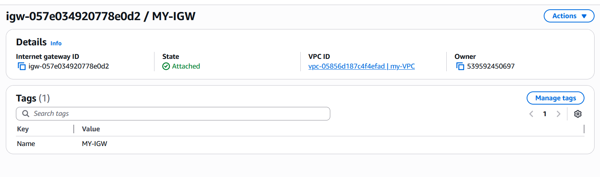
3.Creating Public and Private Subnets with 256 IP address:

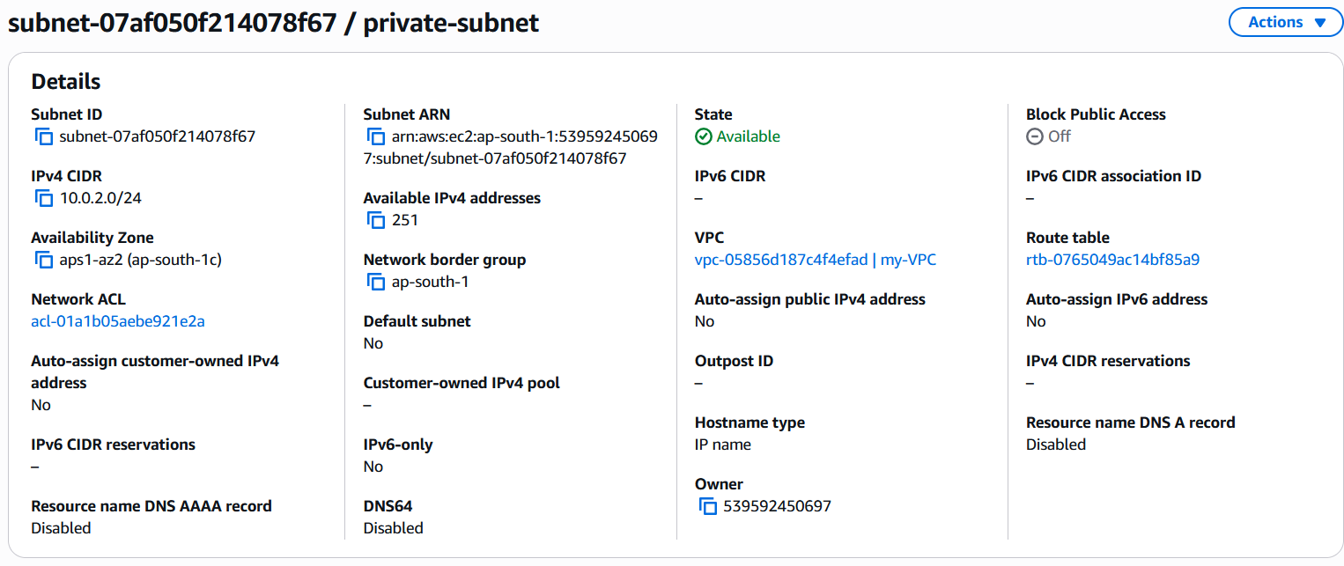
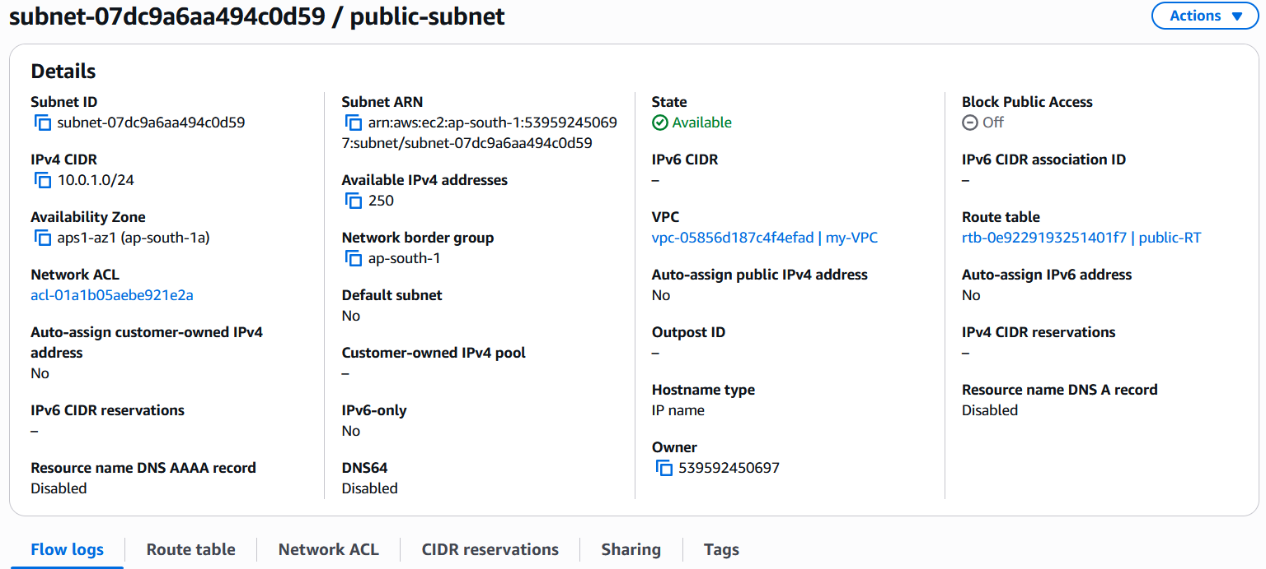

4.Adding MY VPC Internet gateway to Route Table:

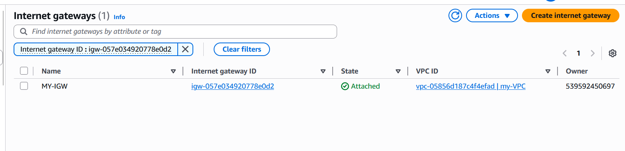
5.Adding Explicit Public Subnet associations in the Route table:

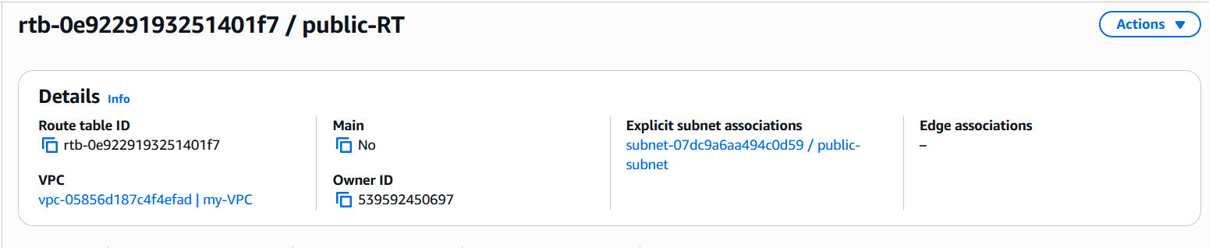

6.Creating Ec2 AWS Linux with the VPC(my-vpc) with public Ip assign option enabled:

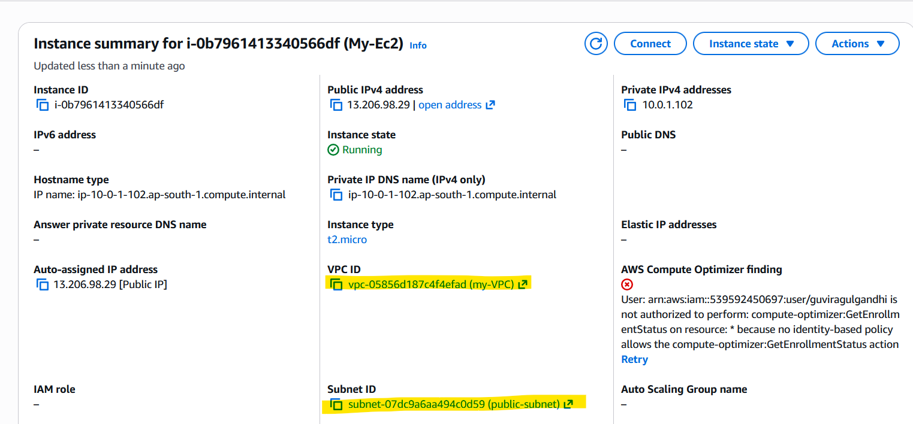

7.Connecting Ec2 instance from console:
